  - Thank you for partnering with Habitat for Humanity and Thrivent in Faith Builds. Together, we’ll give a family the warm embrace of community support as we help them achieve the dream of home ownership!

CUT-AND-PASTE INSTRUCTIONS
We developed this tool to make it easy for you to spread the word about your Faith Build throughout your church. Select the content you’d like to use to create your own bulletin inserts, emails, website content or other communications.

Choose from the following information that you’d like to use—then just copy and paste to create your own promotional materials. You can even customize some sections with details about your church or Faith Builds activities.

We can do more together
Habitat for Humanity and Thrivent are partnering to help make affordable housing a reality for [CITY NAME] through the collaborative Faith Builds program. It’s a partnership powered by faith and a passion to build stronger families, churches and communities.

- Habitat for Humanity is a Christian nonprofit housing organization with a mission to put God’s love into action by bringing people together to help build strength, stability and self-reliance through shelter.

- Thrivent is a membership organization that guides Christians on their Wise With Money Journey, so they can live more content, confident and generous lives. For more than 100 years, Thrivent has helped Christians make wise money choices that reflect their values and offer opportunities to be generous where they live, work and worship.

Since 2005, thousands of home builds and repair projects have been completed by Thrivent members and other generous Habitat for Humanity volunteers. Now, entire churches can help local families in need of decent, affordable housing by joining a Faith Build.
- As members of [CHURCH NAME}, we are called to build community inside and outside of the church. Faith Builds are a meaningful—and fun—way to answer this call!
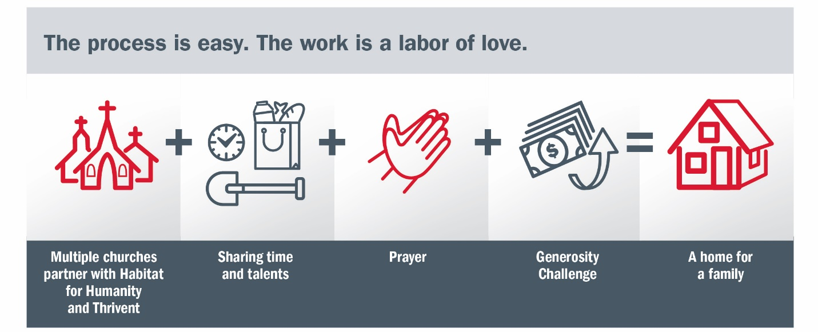

How Faith Builds work
- Churches commit to becoming a partner in the Faith Build.
- Church members generously volunteer their time, choosing to help with construction or non-construction activities.
  - [Volunteer on a build day.]
  - [Make a financial contribution.]
  - [Provide lunch for on-site workers.]
  - [Create a welcome basket or other special items for the family.]
  - [Participate in ground-breaking and dedication events.]
  - [Form a prayer group for the Faith Builds.]
- [Our church, along with other churches in the community/local churches] is participating in a Faith Builds Generosity Challenge:
- Thrivent provides up to 50% of the new home cost.
- [Our church/All participating churches] [is/are] challenged to match the remaining home cost.
- A family moves into their new home!

Faith Builds details
[Include details about the Faith Build (e.g., date, time, location, partner family information).]

Be part of this life-changing experience!
[For more information, contact NAME, at PHONE or EMAIL by DATE/Visit our website, URL HERE, for more information and to sign up for Faith Builds activities.]

SOCIAL MEDIA KIT

Use your social media presence to help raise walls, prayers and funds by raising awareness.

Here are a few suggestions for creating your own social media posts. Personalize each post with your own photos! You can also add dates and times to the post to promote your specific Faith Builds event and activities.

Social Post Examples: Before event

Build with faith! Our church is partnering with Habitat for Humanity and Thrivent in a Faith Build to help a local family build a new home! There are many ways to serve on and off the build site. Learn more: INSERT URL HERE.

Take your faith to the streets … [ADDRESS, CITY] to be exact! Help raise the roof, walls, funds and prayers through a Faith Build. Our congregation is partnering with Habitat for Humanity and Thrivent to help the [LAST NAME] family build a safe, affordable home. See how you can make a difference at:
INSERT URL HERE.

Put your faith into action and help change a local family’s life! Join members of [CHURCH NAME] in a Faith Build to raise the roof, walls, funds and prayers to help the [LAST NAME] family build a new home through a special partnership between Habitat for Humanity and Thrivent.
Find out more at: INSERT URL HERE.

[CHURCH NAME] members: A local family needs our help! We’re partnering with Habitat for Humanity
and Thrivent in a Faith Build for the [LAST NAME] family. And you can make a difference—whether you’re handy with a hammer or want to cook for the crew.

Be part of a Faith Build!
Join other members of [INSERT CHURCH NAME] as we come together to raise the roof, walls, funds and prayers through a Habitat and Thrivent Faith Build. Learn more at: INSERT URL HERE.

Social Post Examples: After event
Note: Be sure to include construction and non-construction photos of your congregation’s activity in support of
the Faith Builds.

Thank you to the members of [CHURCH NAME] who helped [ACTIVITY] on [DATE], who helped raise the roof, walls, funds and prayers for the [ADD NAME] family and our Habitat and Thrivent Faith Build. Together, we made a difference!

By participating in a Faith Build, our church helped the [FAMILY NAME] come one step closer to home ownership. What’s your favorite Faith Build construction or non-construction activity? Share your comments below.

Photo Bank to accommodate messaging:

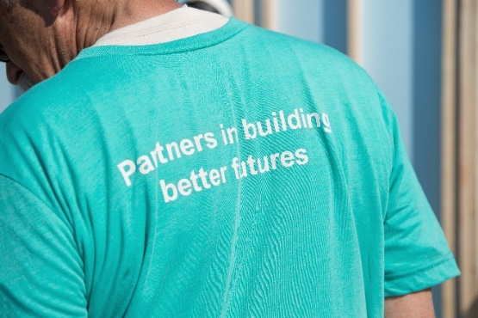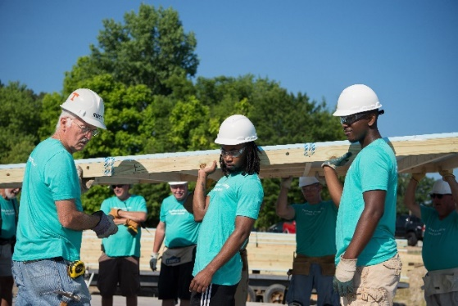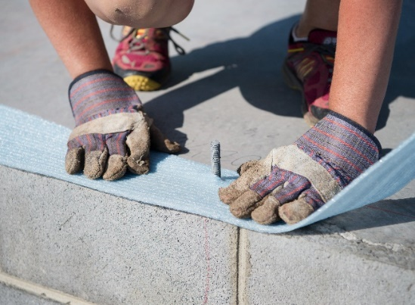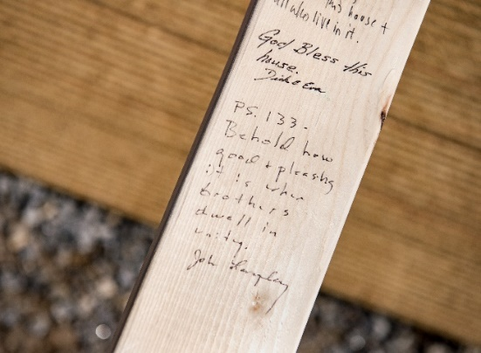
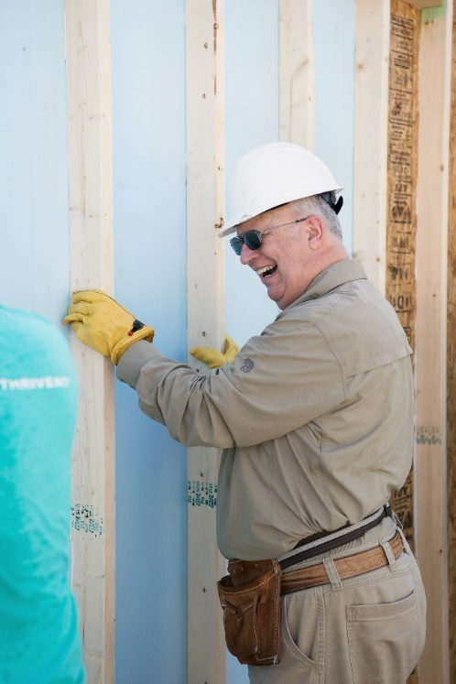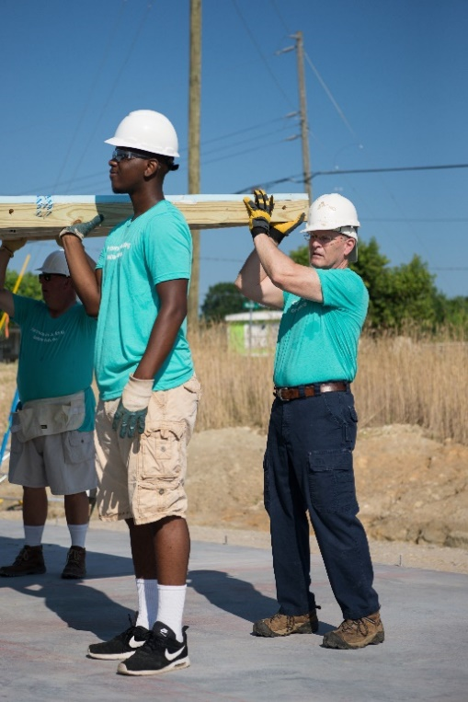
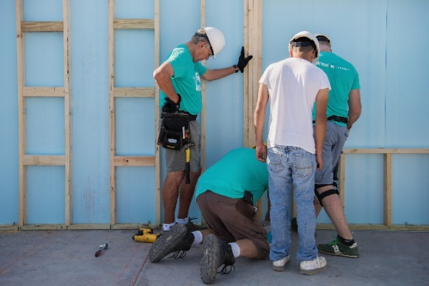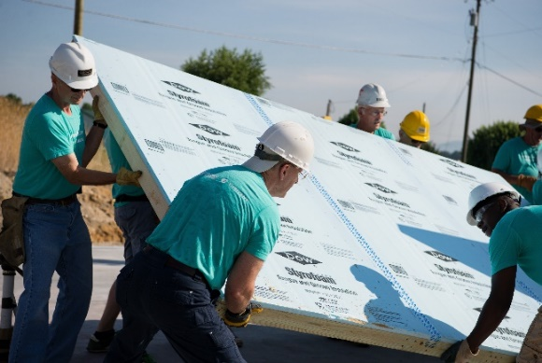
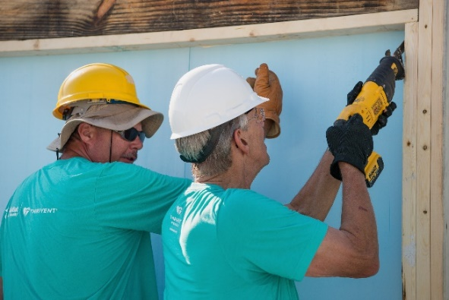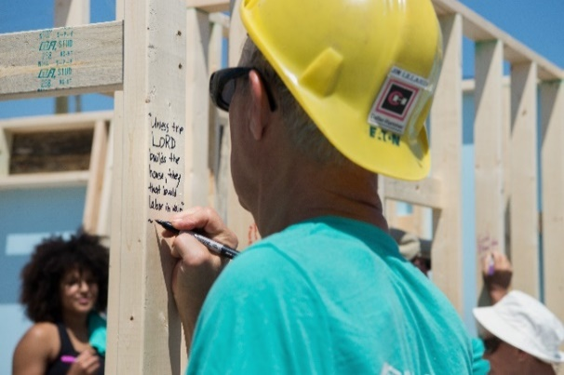
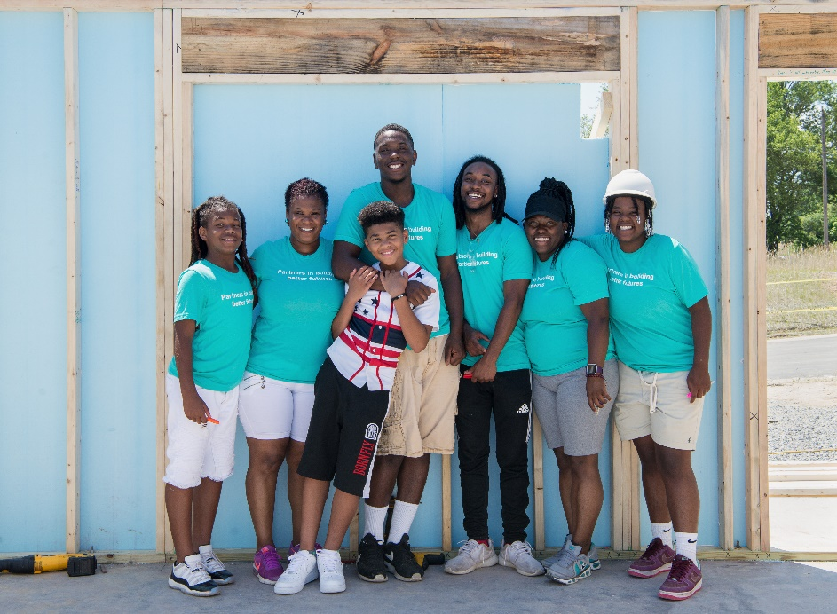
29714A R11-18

